Mid Project Report

Part A: Data Construction and Parameter-Setting:

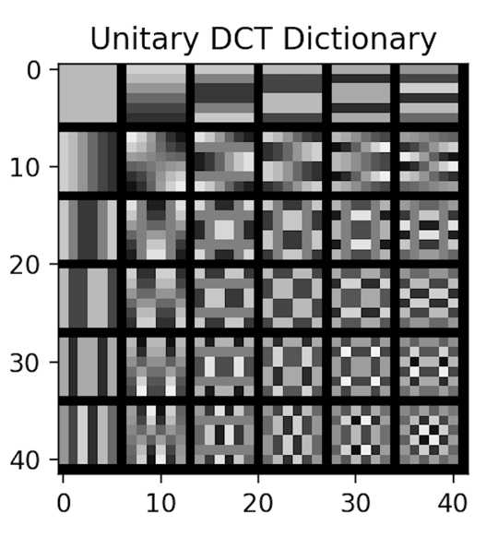

Part B: Compute the Representation Error Obtained by the DCT Dictionary

Insert average MSE for train set: 39.89

Insert average MSE for test set: 32.08

Insert average number of non-zeros for train set: 4

Insert average number of non-zeros for test set: 4

Part C: Procrustes Dictionary Learning

The obtained learned dictionary:

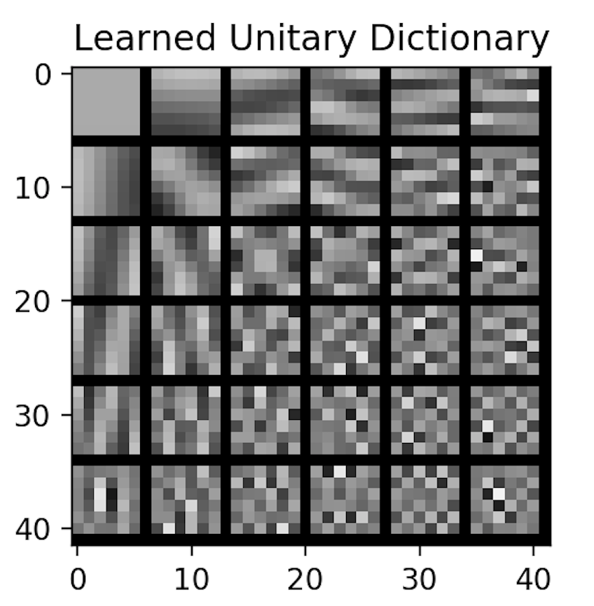

Discuss the obtained dictionary:

Comparing to the initial DCT dictionary, we can see the learned dictionary has adapted to the image. The low frequency atoms vary less while the high frequency ones have undergone more substantial changes.

Average MSE and number of nonzeros as a function of the iteration (train-set):



Discuss the obtained curves:

We can observe that indeed the dictionary is learning. The learning curve slows down but we can expect that if the algorithm iterates longer a lower average MSE can be obtained.

As we perform hard-thresholding, the average number of non-zeros is strictly kept at K = 4. In addition, we can see there’s no “ties” so K = 4 is strictly retained during the whole training.

Insert average MSE for test set: 29.13

Discuss the obtained MSE:

We can see MSE for the training AND test set are both reduced, indicating a dictionary that generalizes better has been learned.

Compare the results of the DCT dictionary and the learned dictionary:

Two observations:

(1). Learned dictionary adapts more in high frequency components, which means it can adapt better to the rich texture of barbara.png.

(2). Both training and test MSE have been reduced, which means the learned dictionary can generalize well to the rest partches of barbara.png.